39. Get the First 3 Rows of a DataFrame

Aim
To write a Python program using Pandas to display the first 3 rows of a given DataFrame.

Algorithm
- Import the Pandas library.
- Create the DataFrame using the given data.
- Use the head(3) function to select the first 3 rows.
- Display the selected rows.
- Stop the program.

Code (Run in IDLE)
import pandas as pd

exam_data = {
'name': ['Anastasia', 'Dima', 'Katherine', 'James', 'Emily',
'Michael', 'Matthew', 'Laura', 'Kevin', 'Jonas'],
'score': [12.5, 9, 16.5, float('nan'), 9, 20, 14.5, float('nan'), 8, 19],
'attempts': [1, 3, 2, 3, 1, 2, 1, 3, 2, 1],
'qualify': ['yes', 'no', 'yes', 'no', 'yes', 'yes',
'yes', 'no', 'no', 'yes']
}

labels = ['a', 'b', 'c', 'd', 'e', 'f', 'g', 'h', 'i', 'j']

df = pd.DataFrame(exam_data, index=labels)

print("First three rows of the data frame:")
print(df.head(3))

Input
exam_data DataFrame containing name, score, attempts and qualify columns.

Output

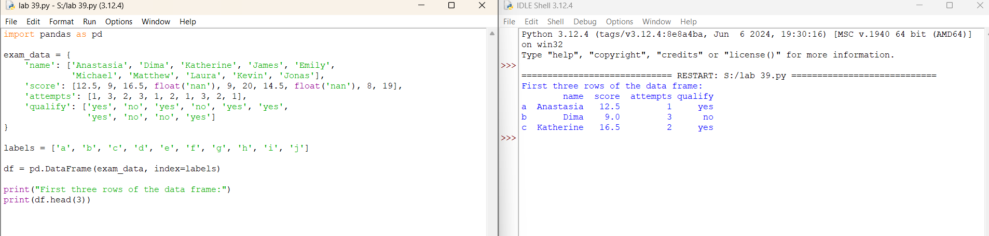

Result
Thus, the Python program successfully displays the first 3 rows of the given DataFrame using the Pandas head(3) function.

40. Select the name and score Columns

Aim
To write a Python program using Pandas to select and display the name and score columns from a given DataFrame.

Algorithm
- Import the Pandas library.
- Create the DataFrame using the given data.
- Select the name and score columns.
- Display the selected columns.
- Stop the program.

Code (Run in IDLE)
import pandas as pd

exam_data = {
'name': ['Anastasia', 'Dima', 'Katherine', 'James', 'Emily',
'Michael', 'Matthew', 'Laura', 'Kevin', 'Jonas'],
'score': [12.5, 9, 16.5, float('nan'), 9, 20, 14.5, float('nan'), 8, 19],
'attempts': [1, 3, 2, 3, 1, 2, 1, 3, 2, 1],
'qualify': ['yes', 'no', 'yes', 'no', 'yes', 'yes',
'yes', 'no', 'no', 'yes']
}

labels = ['a', 'b', 'c', 'd', 'e', 'f', 'g', 'h', 'i', 'j']

df = pd.DataFrame(exam_data, index=labels)

print("Select specific columns:")
print(df[['name', 'score']])

Input
exam_data DataFrame containing name, score, attempts and qualify columns.

Output

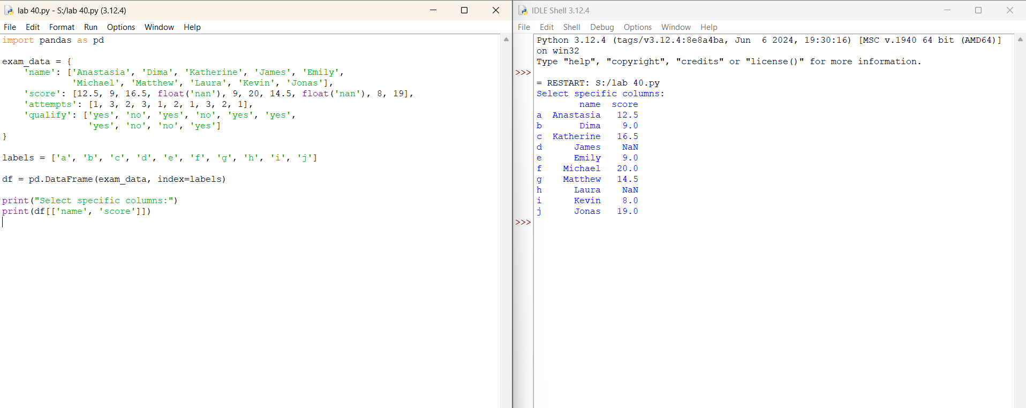Result
Thus, the Python program successfully selects and displays the name and score columns from the given DataFrame.

